BASH basics - Maria Dahmosh – 18/03/2024

**Exercise 1:**

1. --
2. mkdir SecretHideout creating a directory
3. cd SecretHideout Move into the directory
4. mkdir "MissionReports," "TopSecretFiles," "Tools." create three directories inside the hideout
5. ls List the contents of the "SecretHideout" directory



1. cd TopSecretFiles, Move into the "TopSecretFiles" directory
2. touch AgentList.txt Create a file named "AgentList.txt"
3. echo " Maria Dahmosh, Agent2Name, Agent2Name" >> AgentList.txt Add your name and two other agent names to "AgentList.txt".
4. cat AgentList.txt display the contents of "AgentList.txt"
5. cd .. Return to the "SecretHideout" directory
6. touch MissionReports/MissionBriefing.txt Create a text file named "MissionBriefing.txt" inside the "MissionReports" directory.
7. echo "example for mission briefing message text" >> MissionReports,/MissionBriefing.txt Add a mission briefing message to "MissionBriefing.txt"
8. cat MissionReports,/MissionBriefing.txt Display the contents of "MissionBriefing.txt" directly in the terminal.
9. mv MissionReports,/MissionBriefing.txt TopSecretFiles, move "MissionBriefing.txt" to the "TopSecretFiles" directory.
10. mv TopSecretFiles,/AgentList.txt TopSecretFiles,/AgentRoster.txt Rename "AgentList.txt" to "AgentRoster.txt".
11. rmdir Tools. Remove the "Tools" directory and its contents.
12. ls / ls –al Display the contents of the "SecretHideout" directory Display the contents of the "SecretHideout" directory.
13. we can move all text files in the directory by using *

mv TopSecretFiles,/*.txt MissionReports,

1. cd MissionReports, navigate to MissionReports
2. less * Display the contents of the directory
3. pwd >>CurrentLocation.txt Display the current directory path, and redirect (save) the output to a file named "CurrentLocation.txt".

**Exercise 2:**

1. mkdir MusicCollection.
2. cd MusicCollection.
3. mkdir Classical Rock, Pop, HipHop.
4. cd Rock,
5. touch ClassicRock.txt
6. echo "Queen

Pink Floyd

The Beatles" >> ClassicRock.txt

1. cat ClassicRock.txt

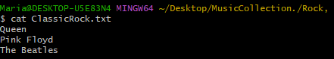

1. cd ..
2. touch Pop,/Top40.txt
3. echo "Bruno Mars

Taylor Swift

Rihana" >> Pop,/Top40.txt

1. cat Pop,/Top40.txt
2. mv Rock,/ClassicRock.txt Pop,
3. mv Pop,/Top40.txt Pop,/HitSongs.txt
4. mkdir HipHop./Featured
5. cd HipHop./Featured
6. touch BestRappers.txt
7. echo "50 Cent

Jay-Z

Eminem" >> BestRappers.txt

1. less BestRappers.txt

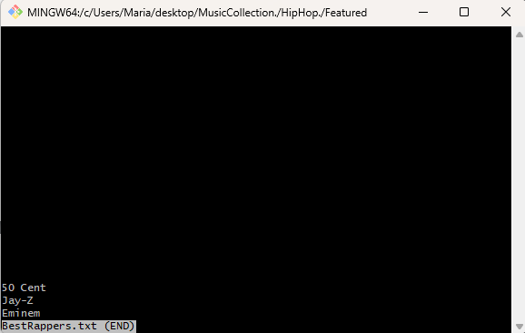

1. cd ~/desktop/MusicCollection./Rock,

rm -r ~/desktop/MusicCollection./HipHop./*

**Exercise 3:**

1. mkdir ServerLogs
2. cd ServerLogs
3. mkdir AccessLogs, ErrorLogs, Reports.
4. cd AccessLogs,
5. touch access.log

notepad++ access.log then copy the data from the data file.

1. Head -10 access.log

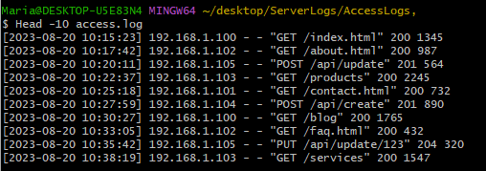

1. Grep "GET" access.log

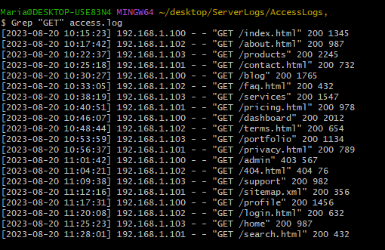

1. grep "192.168.1.104" access.log | wc –l 5
2. notepad++ generate_report.sh

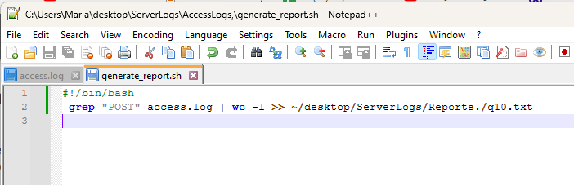

#!/bin/bash

grep "POST" access.log | wc -l >> ~/desktop/ServerLogs/Reports./q10.txt

1. chmod +x generate_report.sh
2. ./generate_report.sh

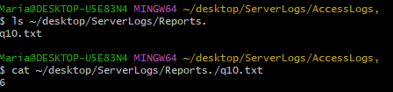

1. cd ~/desktop/ServerLogs/ErrorLogs,
2. notepad++ error_summary.txt then copy the data from the error data file.
3. ---
4. ---
5. du –sh ~/desktop/ServerLogs

